

Massachusetts Department of Public Health JANUARY 2016

**Data Brief: Confirmed Unintentional/Undetermined1 Opioid-related2 Overdose Deaths Among Massachusetts Residents – Demographic Data Highlights**

This data brief highlights demographic data from confirmed overdose deaths from January through September of 2015.

**Confirmed Unintentional/Undetermined1 Opioid Deaths by Gender:   
January-September 2015**

|  |  |
| --- | --- |
| **Unintentional/Undetermined Opioid Deaths by Gender: January-September 2015** | |
| Male | 604 |
| Female | 187 |
| Total | 791 |

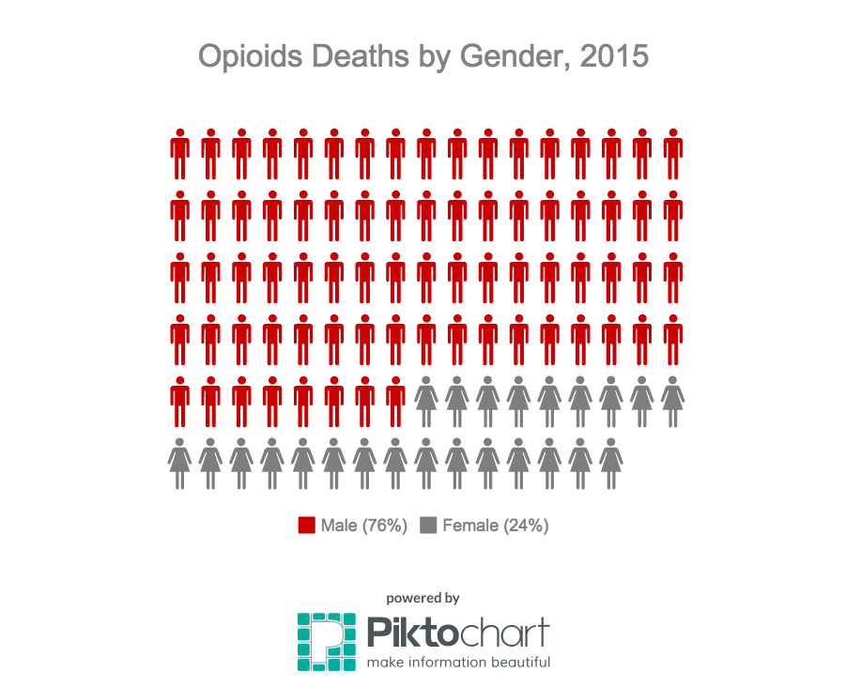

1 Unintentional poisoning/overdose deaths combine unintentional and undetermined intents to account for a change in death coding that occurred in 2005. Suicides are excluded from this analysis.

2 Opioids include heroin, opioid-based prescription painkillers, and other unspecified opioids.

**Confirmed Unintentional/Undetermined1 Opioid Deaths Compared to All Deaths by Age   
January-September 2015**

|  |  |  |  |  |  |  |  |  |
| --- | --- | --- | --- | --- | --- | --- | --- | --- |
|  | **Confirmed Unintentional/Undetermined1 Opioid Deaths by Age January-September 2015** | | | | | | |  |
|  | 0-14 | 15-24 | 25-34 | 35-44 | 45-54 | 55-64 | 65+ |  |
| 2015(Jan-Sep) | 0 | 81 | 247 | 203 | 178 | 78 | 4 | 791 |

|  |  |  |  |  |  |  |  |  |  |
| --- | --- | --- | --- | --- | --- | --- | --- | --- | --- |
|  | **All deaths by age**  **January-September 2015** | | | | | | | | |
|  | 0-14 | 15-24 | 25-34 | 35-44 | 45-54 | 55-64 | 65+ | Unknown |  |
| 2015 (Jan-Sep) | 294 | 358 | 808 | 970 | 2332 | 4514 | 33404 | 4 | 42684 |

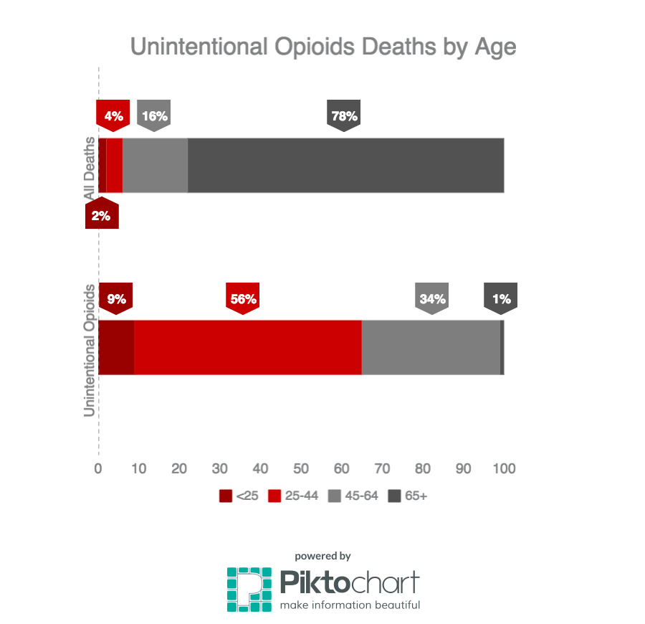

1 Unintentional poisoning/overdose deaths combine unintentional and undetermined intents to account for a change in death coding that occurred in 2005. Suicides are excluded from this analysis.

**Confirmed Unintentional/Undetermined1 Opioid Deaths Compared to All Deaths by Race  
January-September 2015**

|  |  |  |  |  |  |  |
| --- | --- | --- | --- | --- | --- | --- |
|  | **White non-Hispanic** | **Black non-Hispanic** | **Asian non-Hispanic** | **Hispanic** | **Other/**  **Unknown** | Total |
| Unintentional/Undetermined1 Opioid Deaths | 659 | 40 | 3 | 74 | 15 | 791 |
| All Deaths | 38241 | 1763 | 782 | 1492 | 406 | 42684 |

**Unintentional/Undetermined1 opioid deaths, compared to all deaths:**

**January 2015-September 2015**

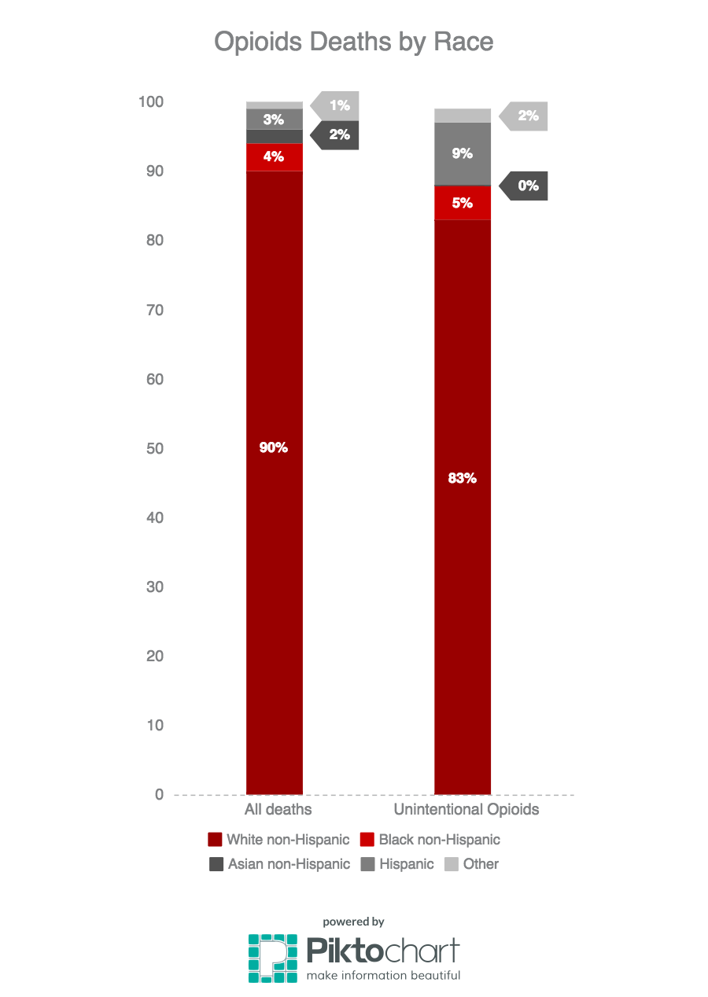

1 Unintentional poisoning/overdose deaths combine unintentional and undetermined intents to account for a change in death coding that occurred in 2005. Suicides are excluded from this analysis.

**Technical Notes**

1. 2014 and 2015 death data are preliminary and subject to updates. Case reviews of deaths are evaluated and updated on an ongoing basis. A large number of death certificates have yet to be received from the municipalities and some have yet to be assigned cause-of-death codes. The information presented in this report only includes confirmed cases. Data updated on 12/10/2015.

**Source: Registry of Vital Records and Statistics, MDPH**